Load Unstructured / Semi-Structured Data in Snowflake (JSON → VARIANT → Flatten)

Overview Flow
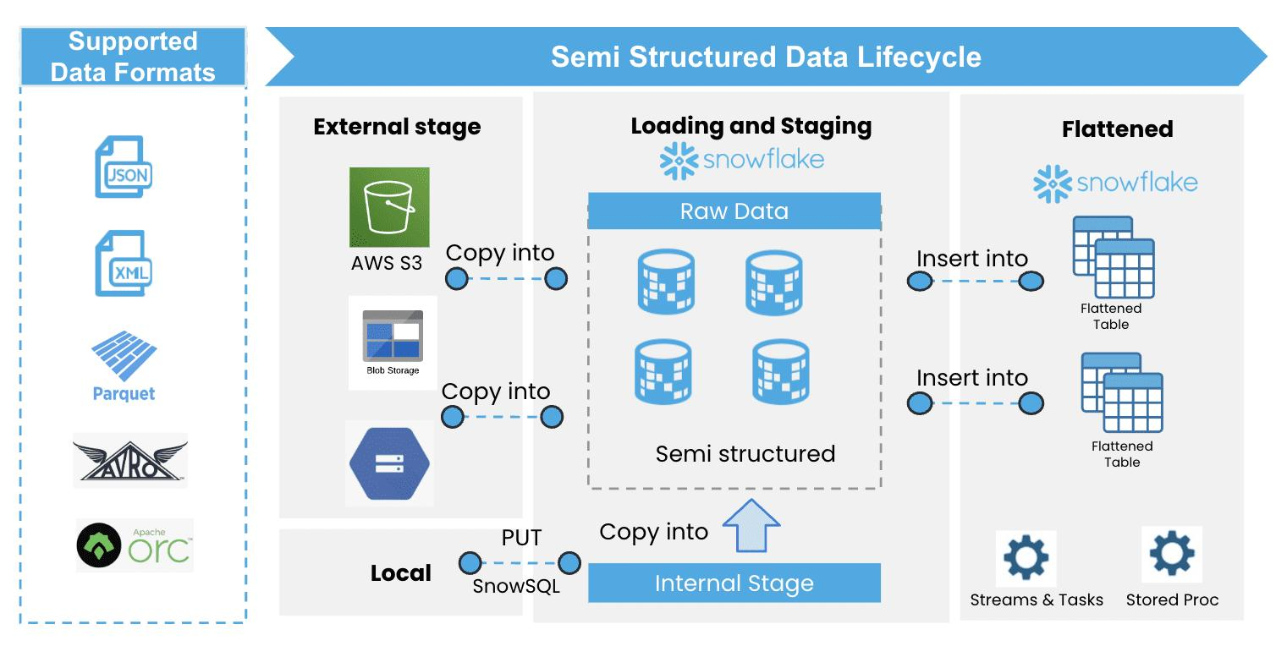
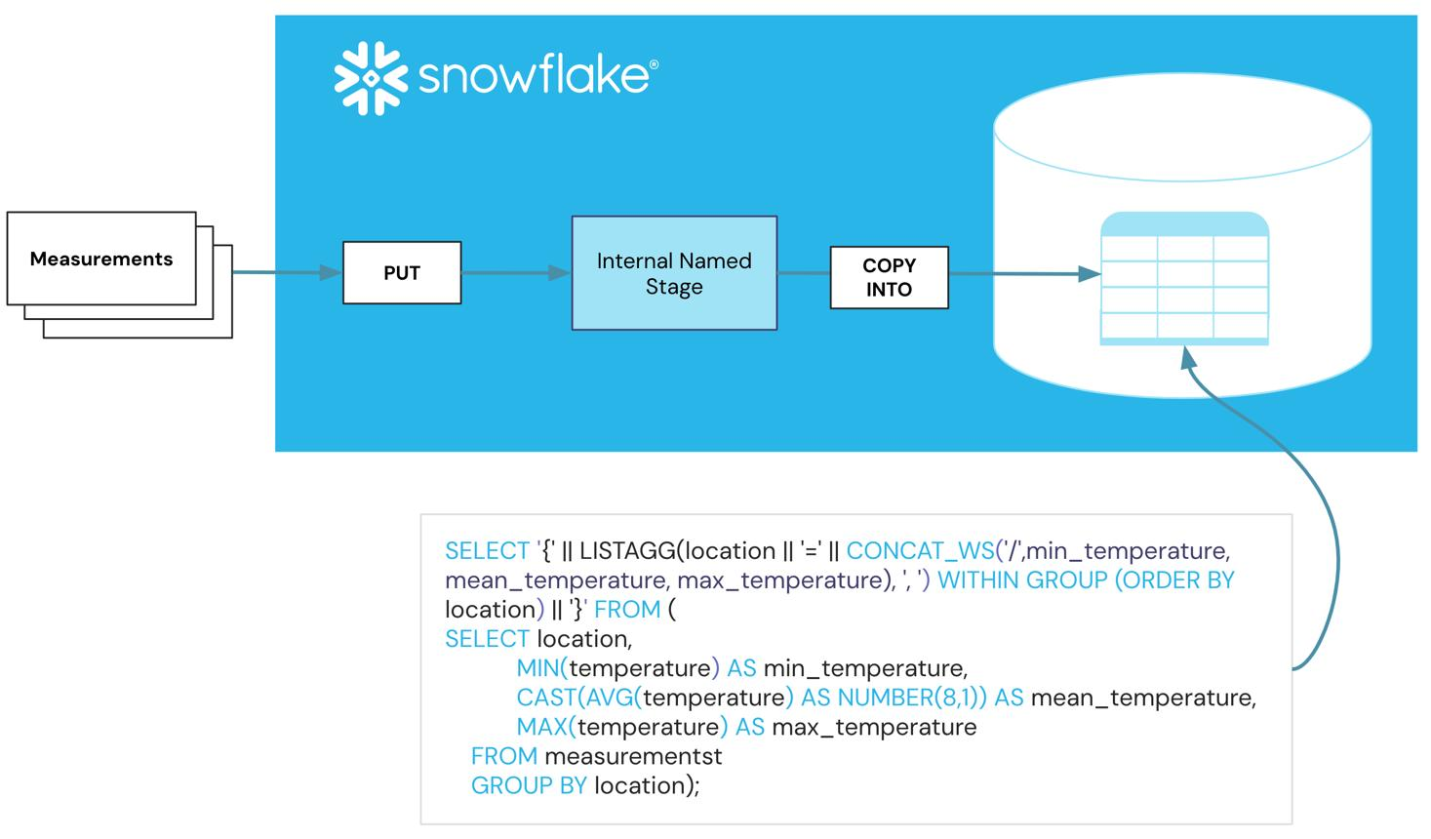
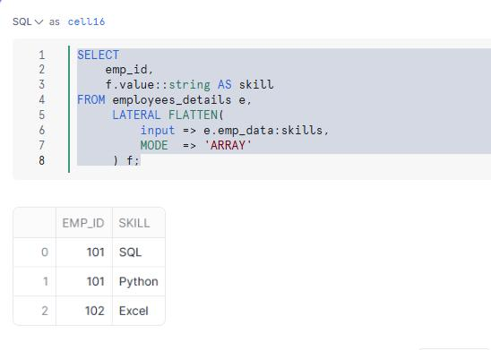
You will implement:
- Create Stage (external/internal)
- Load Raw JSON into Snowflake (VARIANT)
- Analyze & Parse JSON
- Flatten & Transform into Structured Table

Lab Prerequisites
- Snowflake account
- Warehouse + Database + Schema
-- Setup
CREATE WAREHOUSE demo_wh WAREHOUSE_SIZE = 'XSMALL';
CREATE DATABASE demo_db;
CREATE SCHEMA demo_schema;
USE WAREHOUSE demo_wh;
USE DATABASE demo_db;
USE SCHEMA demo_schema;

Step 1 — Create Sample JSON File
Create a file orders.json locally:
[
{
"order_id": 101,
"customer": "Vikash",
"items": [
{"product": "Laptop", "price": 800},
{"product": "Mouse", "price": 20}
],
"location": {"city": "Bangalore", "country": "India"}
},
{
"order_id": 102,
"customer": "Rahul",
"items": [
{"product": "Phone", "price": 500}
],
"location": {"city": "Delhi", "country": "India"}
}
]

Step 2 — Create File Format (JSON)
CREATE OR REPLACE FILE FORMAT json_format
TYPE = 'JSON';

Step 3 — Create Stage
Internal Stage
CREATE OR REPLACE STAGE my_stage
FILE_FORMAT = json_format;

Step 4 — Upload File to Stage
Option 1: Using SnowSQL
PUT file://orders.json @my_stage;
Option 2: UI (Snowsight)
- Go to Data → Stages
- Upload file manually

Step 5 — Create Raw Table (VARIANT)
CREATE OR REPLACE TABLE raw_orders (
data VARIANT
);

Step 6 — Load Raw JSON Data
COPY INTO raw_orders
FROM @my_stage/orders.json
FILE_FORMAT = (FORMAT_NAME = json_format);

Step 7 — View Raw Data
SELECT * FROM raw_orders;
You will see JSON stored inside VARIANT column

Step 8 — Analyze & Parse JSON
Access fields using : operator
SELECT
data:order_id::INT AS order_id,
data:customer::STRING AS customer,
data:location.city::STRING AS city
FROM raw_orders;

Step 9 — Flatten Nested Arrays
Here comes the key step: FLATTEN
SELECT
data:order_id::INT AS order_id,
data:customer::STRING AS customer,
item.value:product::STRING AS product,
item.value:price::INT AS price
FROM raw_orders,
LATERAL FLATTEN(input => data:items) item;

Step 10 — Create Structured Table
CREATE OR REPLACE TABLE orders_final (
order_id INT,
customer STRING,
product STRING,
price INT,
city STRING,
country STRING
);

Step 11 — Insert Flattened Data
INSERT INTO orders_final
SELECT
data:order_id::INT,
data:customer::STRING,
item.value:product::STRING,
item.value:price::INT,
data:location.city::STRING,
data:location.country::STRING
FROM raw_orders,
LATERAL FLATTEN(input => data:items) item;

Step 12 — Validate Final Output
SELECT * FROM orders_final;
Expected output:
order_id | customer | product | price | city | country
101 | Vikash | Laptop | 800 | Bangalore | India
101 | Vikash | Mouse | 20 | Bangalore | India
102 | Rahul | Phone | 500 | Delhi | India

